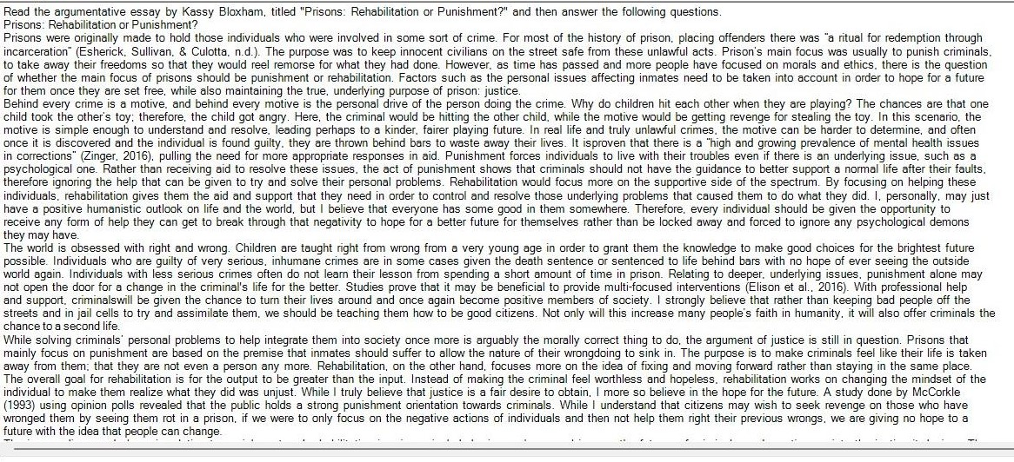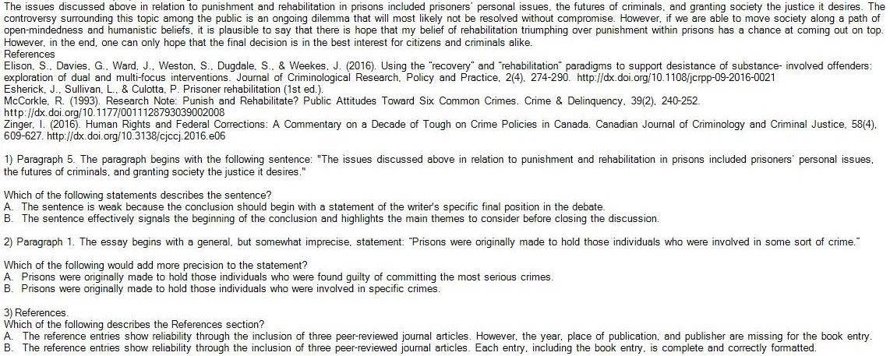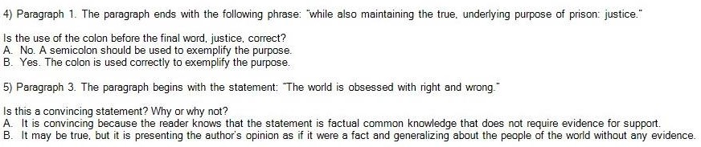

DAP AN  
1.B. The sentence effectively signals the beginning of the conclusion and highlights the main themes to consider before closing the discussion.

2.B. Adding more precision to the statement would involve specifying the types of crimes or the legal criteria used to determine which individuals are held in prisons.

3.A. The reference entries show reliability through the inclusion of three peer-reviewed journal articles. However, the year, place of publication, and publisher are missing for the book entry.

4.B. The colon is used correctly to exemplify the purpose.

5.B. It may be true, but it is presenting the author's opinion as if it were a fact and generalizing about the people of the world without any evidence.